**THE HONG KONG POLYTECHNIC UNIVERSITY**

**Department of Electronic and Information Engineering**

**EIE4108: Distributed Systems and Cloud Computing**

**Lab 3: Big Data Analysis with Hadoop**

**Lab Report**

**Name: Sze Kin Sang**

**Student ID: 19062606D**

**Question #1:**

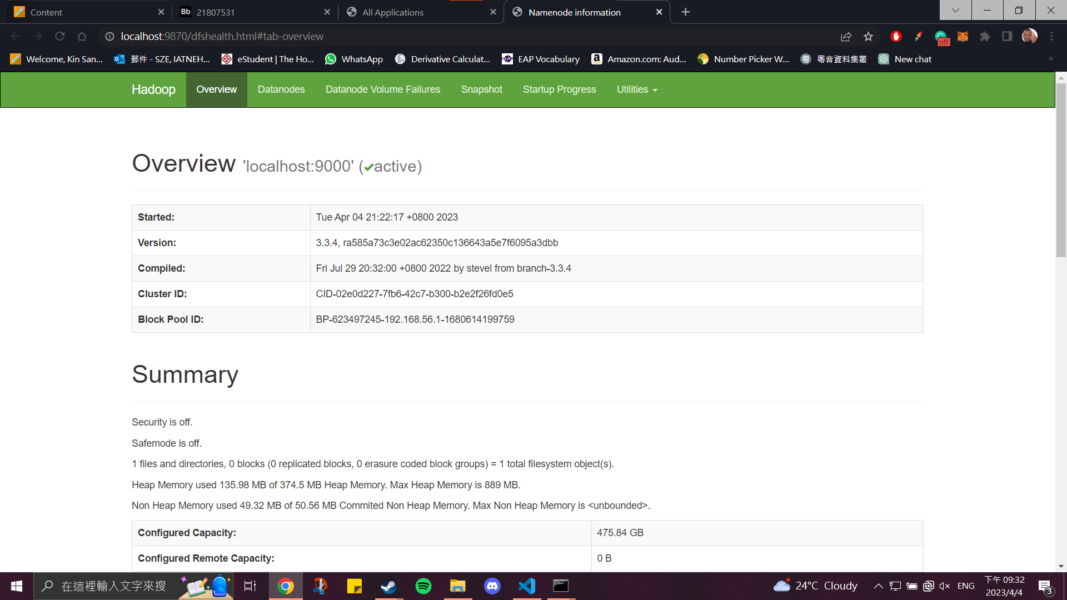

**Question #2:**

**Question #3:**

**Question #4:**

According to the ouput, customer 2 spent the most over the year while customer 6 makes the highest fluctuation in the sales figures.